* This app is an app serve people to make their life easier, in such way they can book many things online where they don't have to go to book it or purchase it .
* This app will be at least 6 months' bugs free from programmer.
* This app will use API and Server .
* Google map, calendar, sms API's.
* Maybe there I forgot some function that I couldn't cover so once I remember it I want you to implement it but for sure it won't be hard ☺
* User cannot promote himself directly as shopper, he must go to Sliding menu then click on ADD YOUR SERVICE ,from that place Admin will receive his application then admin will decide whether to place it or not, and another note related to that is admin will have with his panel a function to make any user shopper just by his phone number.
* For the server I don't have great view or how I'm going to expect the server to be implemented so for that I want you to give me idea or show me some database so I can know what I want but as start I want every logs, orders, location of everything(UI so I can input the location of shops)), give access to shops , add new service not categories such things like this.
* Admin can see how many orders need Teacteam interfere and how they handle the order whether thy solve it or not full monitoring
* For shop they will get notification when there is new order from user along with teachteam and this will be also saved in orders history in server
* every shop has his own basket user will not be allowed to exit from the shop unless he checkout--if user wants to exit from shop and he didn't checkout while he add some item in his basket, an pop up message will appear to him says that he need to checkout before exit from shop, after this message appearance a basket will appear to the user to see his orders and then he can go to check-out and decide his favorite date
* every pic in the app need to be cheched in user phone and make app look for updates every time user open the app , for example if user open the app ,app will ask server if there is new updates if yes then only download the newer one if no then remain with the oldest one

Pages of the app

Beauty category:

We will give shop the ability to add pages as he likes but there is two main pages they will be as default

Productive families:

There will be 3 pages and the fourth one is the last one

Candy And Pies:

There is 2 pages and the third one is the last one

House Service:

Only two pages and the second page user can select multiple service.

Other's:

Same as House Service.

* so for the beginning I want to discuss first Page of the UN app which is sign up page:

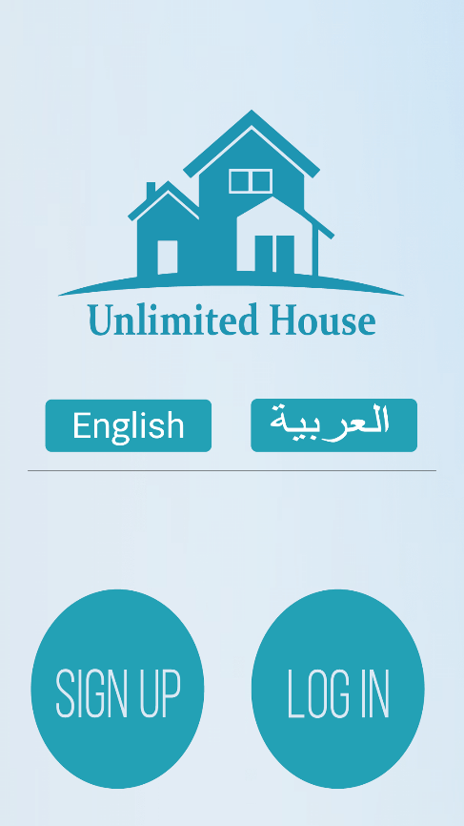

When user click on of the buttons it must show user where he input not like dead button if it's good to say it

LOG IN: this will forward user to screen where he will input his number, server will check if the phone number is existing or not and he have to verify it again if the number is on the database then server will direct user to the screen whether he is shop or costumer or TechTeam

SIGN UP : this will forward the users to the next interface where he should input his number.

LANGUAGE: this app has two language one is English second one is Arabic (I will translate all the English text).

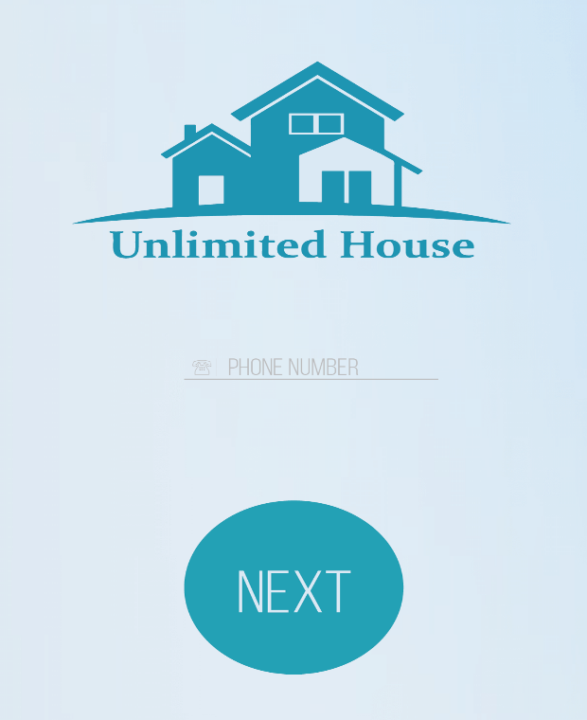

When user click button

it must show user where he input like small small circle colored with brighter blue not like dead button if it's good to say it

Phone Number: where user has to input his number in form of +966_nine number and must its start with number 5

if user start type his number with 0 then let him do that but after he finish an pop up message will cancel his First Zero number and show his number in international form whether he is correct or not

After user input his Phone number an sms will reach his phone with the verification code

Next: will forward user to the next interface

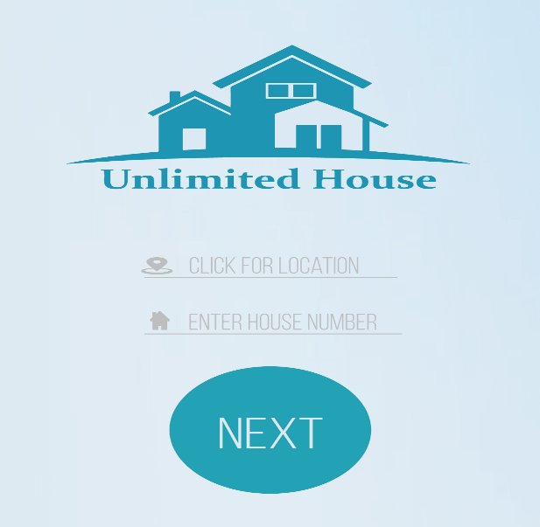

Location: we will use here Google Map API for determining user location and save it to the server , we must be aware about location accurate, since it's may came with 20 meter or even sometimes up to 1 km which is not helpful so we must wait and show what we do to the user that we want accurate location so we could help him better and if the location can't be determinate accurate ,he can put pin to his exact location(see APP flow for better understanding )

House: user simply enter his house number

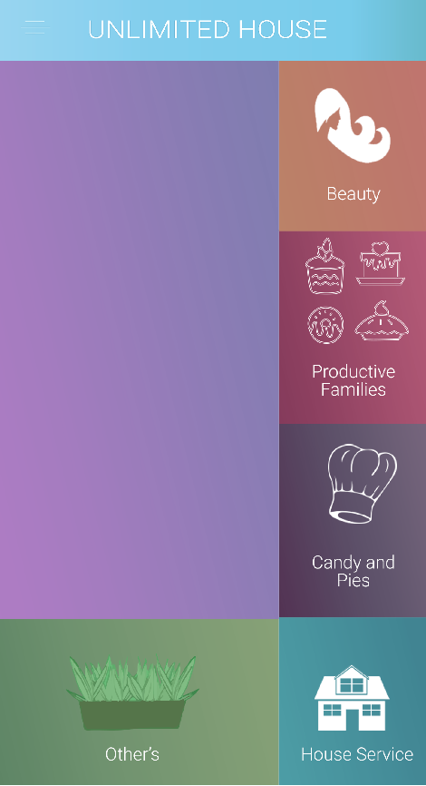

Main menu for users :

There is 5 Cat each on of them provide different function compared with each others

Burble: This big burble place is for "advertising" this will be controlled from web server.

Main menu must not move or anything I mean must not scroll down or up

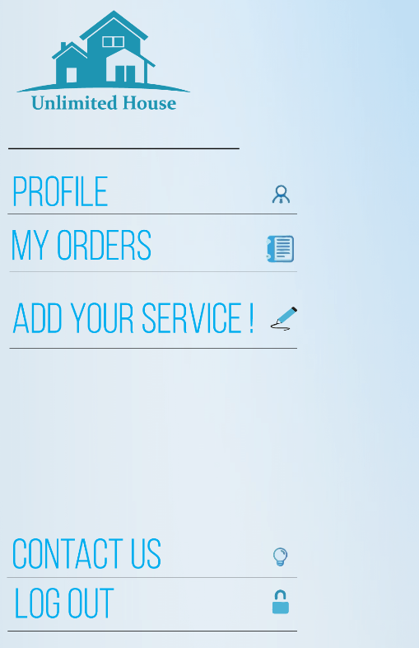

This is the Sliding menu

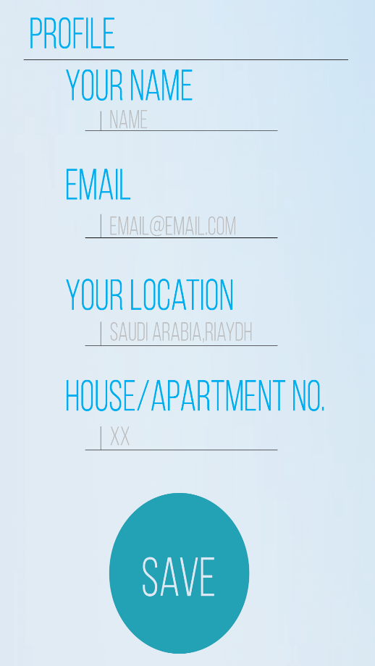

Profile: will move the user to a page where he can update his info and then forward this info to the server ,server must duplicate his info not delete the previous one just duplicate it.

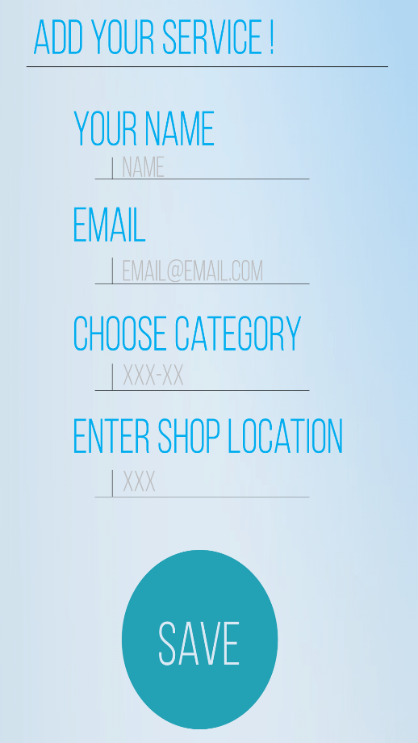

Add your service: this will help shops or even user to list their service in the app ,they will have to fill the info ,when user click on choose category , app will show him the list of main categories so user will select one of them ,after he fill all the info this info going to be redirected to Techteam by notifications so they can handle the request along to the admin , server, email of the app.

Location: at this user will see a pop up message asking him whether he as shop or individual person, then he will see google map location service ,google map will start from his recent location and if user hasn't open his location then app will ask him to open it if user agreed then app will move open location automatically

Contact us from slide menu :

Nothing special only bar to write user feedback and forward to app email and admin along with the server.

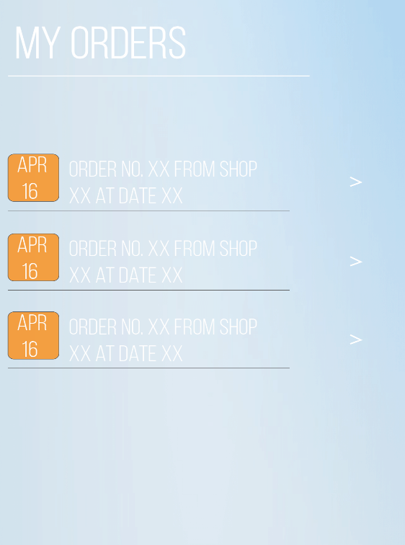

MY ORDERS: list of user orders pic tell everything, but there is an arrow will forward user to the order status.

User also can cancel the order if he order it by mistake

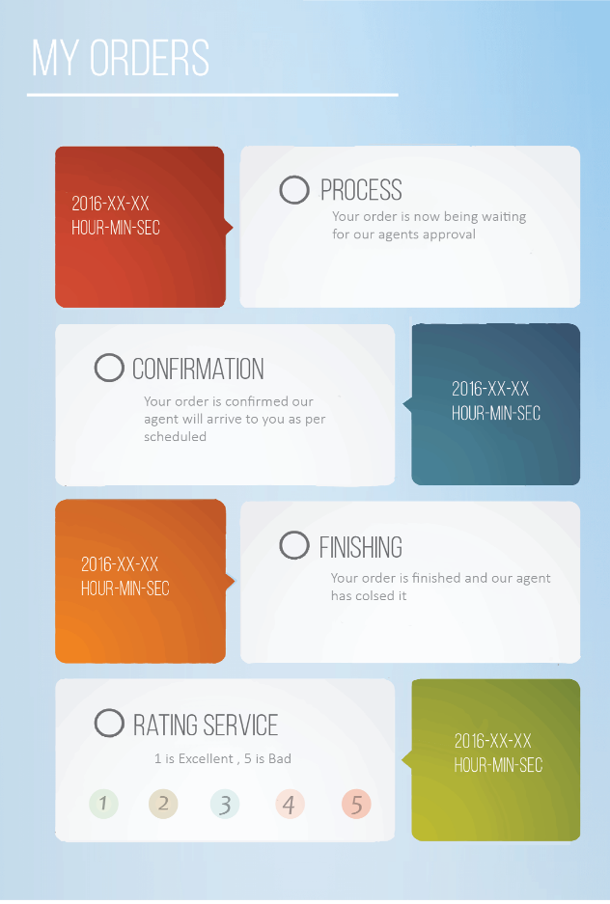

Here every rectangle will appear after it's turn came for example user order something then he only see process after the confirmation came from shop he will see it BUT Finishing the order from both of side user and shop and if one of them didn't close it then it will be closed automatically after 3 days and we will ask user to rate the shop with notification

I think u have to notice there is no bar showing the back button and sliding menu button so kindly implement this

Now we will move to the Beauty Cat

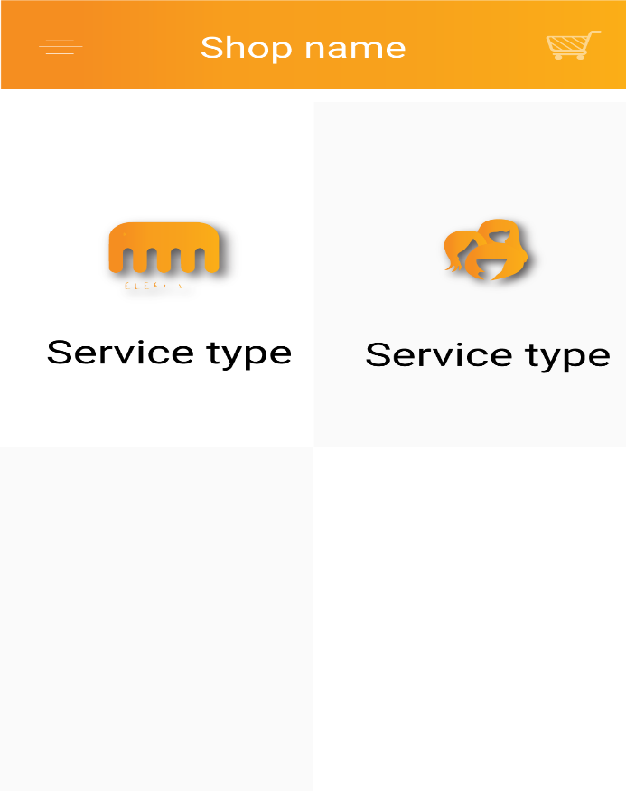

This category will provide the seller ability to add more pages customize more

For example :

Beauty>shop name>some service >sub of that service, more sup.

Beauty>shop name2>some service.

So it's up to the shop to customize his page or if it's good to say his shop inside my app.

In this category costumer will have choice to share his exact location with user or not

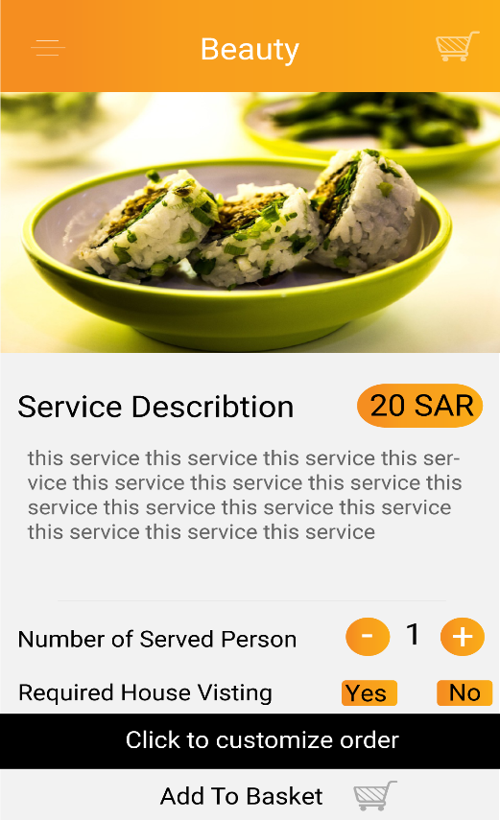

Number of person will be served: this is how many user required this service and price will rise accordingly

Required House Visiting: If user select Yes then user location will be send to the shop once user checkout and if No then pop up message will appear to the shop, shop also have the ability to cancel this choice maybe they didn't provide this service

Click to customize the order: if user click it then he will have the ability to add his needs and shop will see it if shop has issue he can directly contact with Techteam.

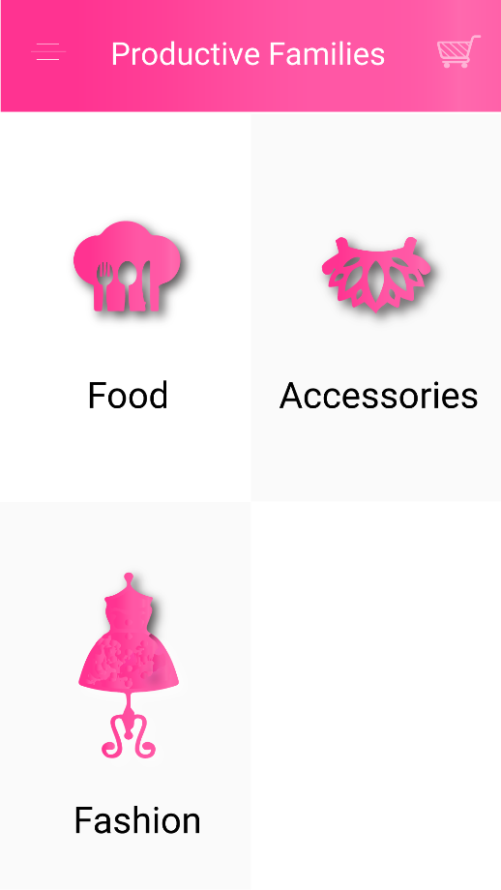

Shop will have ability to add counter per G , KG or pieces

This cat will have 4 pages as following example:

Productive families>Fashion>name of family>list of item>item details.

In (Name of family) ,shop will not have ability to add or remove pages like Beauty but still he can upload pic add squares .

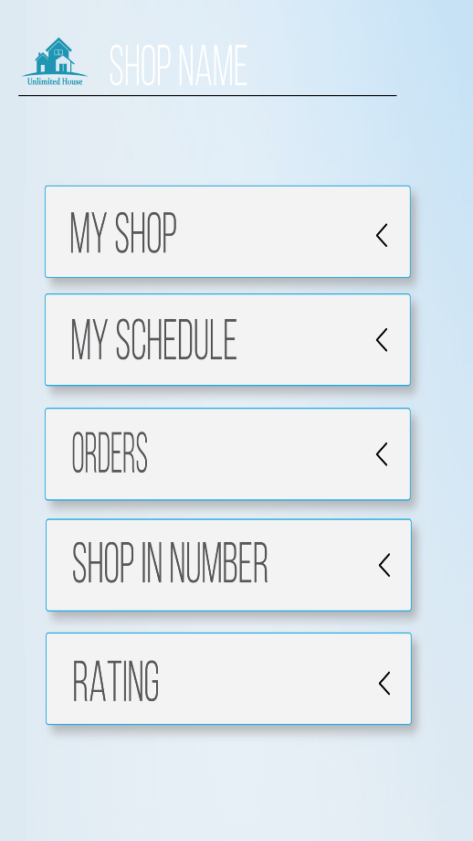

Shop interface

My shop

functions:1-suspend selling temporary

2-add pages

3-add pics write prices ,info ...etc.

4-ability to see how many one order this item

5- for beauty only they have ability to cancel the choice of House visiting or not .

my schedule

functions:1-see a date ,time table to see where is the order placed and when it's supposed to be deliver to costumer

2-can add busy time in calendar where shop cannot serve more users.

3-can cancel order if he couldn't do it after his acceptance.

4-shop will have the ability to add the lowest time for starting the orders this will reflect the time when costumer want to order something and deliver it asap so he have to choice time after that time

For example time is 10:00 pm there is an special type of item and shop need at least 30 min to finish it and 45 min to deliver it so user will see the calendar after 11:05 pm ,

5-browser all months .

6-user can see busy time in the calendar it just see them as busy and he can choose different time but he cannot choose previous dates or times

Orders:

functions:1-see orders in details except costumer phone number it must be forbidden, only for beauty shop they can see numbers if they will come to the shop then no need for it

2-can cancel order.

3-can see if there is new orders.

4-can send cancel orders

5-order will not take more than 5 minutes to give respond to the user first 3 min is between shop and user if shop didn't accept it , then the request will be moved to the Techteam and they can see all Shop phone numbers along with their location so they can decide or handle it manually and give confirmation or declination for user

shop in number:

it's like fact or infographic about his shop status.

functions:1-from which item users mostly ordered

2-at which time he get most of the orders

CONTACT TECHTEAM (INSTEAD OF RATING) :

functions:this will open direct conversation with techteam incase shopper wants something or he had some issues.

Reference app:

<http://store1.up-00.com/2016-04/146116978725311.png>

<http://store1.up-00.com/2016-04/146116978730862.png>

<http://store1.up-00.com/2016-04/146116978737353.png>

Techteam interface

For this interface I don't have much experience to think how the Techteam going to monitor the app , I believe good programmer know what I mean , so if u can provide for me some referencing app ,pages to understand it better and tell you what function I want , but Techteam will help to connect user with shop if shop didn't accept the order so they will get notification along with history in the app to see what shop didn't answer or accept the order ,and see shop number with user details to call shop manually and check whether he going to accept it the order or no and sometime to call costumer if they wants to communicate with Techteam.